Investigating Interview Techniques

By Eoin Godfrey

During this assignment, I will discuss three different interviews which I watched for my PowerPoint Presentation on the subject. These interviews included an interview with Mark Hamill discussing the newest Star Wars film with James Arnold Taylor; I have also included interviews with Robert Downey Jr being interviewed Kristan Guru Murthy about the upcoming superhero film “Age of Ultron” and finally, I will also discuss an interview between Graham Norton and Family Guy creator Seth McFarlane. I will analysis the question types, the style of interview, the purpose of the interviews and the form of media that the interview is on.

**Interview 1: James Arnold Taylor and Mark Hamill**

In this first interview; interviewer James Arnold Taylor interviews actor Mark Hamill and discusses the upcoming movie “The Force Awakens”. This was a structured interview and as the interviewer was reading questions from a page, but it seemed it like the two were having a normal conversation like they were friends. Mark then goes to talk about his experience on the original Star Wars films, the set was comfortable and consisted of a sofa, TV screen and various Star Wars memorabilia; this made for a comfortable and welcoming setting for Mark, as seen in the photo above.

The questions that Mark is being asked are generally about the actor’s experience in the making of the original Star Wars Trilogy such as Open questions that allow Mark to elaborate on his answers, for example; Mark was asked about respiring his role as Luke Skywalker in the new Star Wars film; he was able to go back and forth from the original trilogy to the new one, reflecting on a question he was asked in 1977 by director George Lucas about respiring his role in 2011. Mark was able to elaborate on his answer, go back and forth between the four films; this is a moving image interview and is targeted at Star Wars fans and was filmed at Star Wars Celebration Live Anaheim 2015; this was also a promotional interview for the upcoming film “The Force Awakens”.

Link: https://www.youtube.com/watch?v=p-VQiOhsNmk

**Interview 2: Kristan Guru Murthy and Robert Downey Jr**

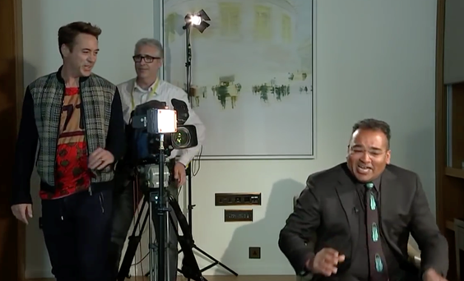In this second interview that I will look at, which is a moving image interview; Kristan Guru Murthy interviews actor Robert Downey Jr, this interview was a promotional interview for the upcoming Marvel movie; “Avengers: Age of Ultron”. The interview starts off like a normal promotional interview with the interviewer asking questions about the film and the characters that it’s based on; he also asks Robert if he bases the character of Iron Man on himself, these open questions are light-hearted and very innocent; this allows the interviewee to elaborate on his answers.

However, as the interview goes on, the interviewer began to ask more off-topic questions and delve more into the interviewee’s personal life that mad e the interviewee very uncomfortable and because of it, the Robert Downey Jr decided to leave the interview early because he was uncomfortable answering these questions and felt like he was being interrogated. The set in this interview was bland with only few props and two chairs facing each other; in my opinion, this was used to make Robert Downey Jr as uncomfortable as possible. As seen in other interviews, the interviewer lets to be controversial, so this can be classed as a structured interview. This interview would have be directed at the general audience of the Channel 4 news programme and also directed at comic book fans that were waiting for of the “Age of Ultron” in cinemas.

Link: https://www.youtube.com/watch?v=ALBwaO-rAsE

**Interview 3: Graham Norton and Seth McFarlane**

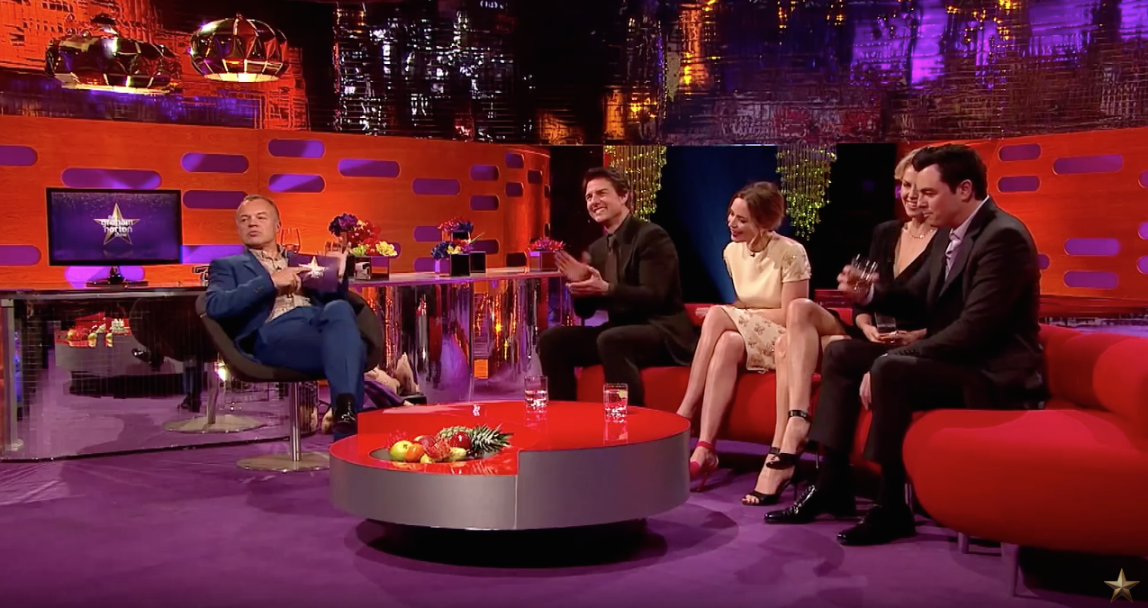In this final interview; I will study an interview between Graham Norton and Family Guy creator Seth McFarlane, this is a moving image interview where Seth talks about the origin of the different voices that he uses for each of the Family Guy characters and also does impressions of each character as well as he goes along. The questions that Seth is asked in this interview are open and very light-hearted as if he and Graham are just having a normal conversation with a friend; which is reflected on the set design, which is very welcome and homely for Seth and makes him feel very comfortable.

Graham and Seth also have a good laugh with each other as Seth does impressions of the different characters that he voices in Family Guy while he talks about where each of the voices originally came from, such as how many of the characters from the show are inspired by different things from his childhood; such as 1950’s radio commercials and people he knew in his neighbourhood. This interview with Seth is geared towards the viewers of the Graham Norton Show and the general audience of the BBC altogether; the interview would also be geared towards fans of the Family Guy TV show that Seth McFarlane created.

Link: https://www.youtube.com/watch?v=AP_aom1IgqI